Customer Support Agent Evaluation Report
Evaluation journey findings prompt improvement trace analysis and LLM judge calibration
150  Labeled tickets | 94.0%  Baseline accuracy | 99.3%  Improved accuracy | 9 of 9  Target failures fixed

This report explains how we reviewed the supplied ground truth, analyzed recurring errors, established a reproducible baseline, tested one focused prompt change, inspected LangSmith traces, measured regressions, and calibrated an optional LLM judge.
Model | Nebius openai gpt oss 120b
LangSmith project | customer support evals
Evaluation date | September 6 2026

Executive Summary
The controlled prompt change improved routing accuracy from 94.0 percent to 99.3 percent. It corrected all nine Account Workflow Missed failures and introduced one regression. The improved run met the declared quality and latency thresholds, although average token usage increased by 24.4 percent.

Evaluation One Liner
We measured exact match routing accuracy, account workflow failure count, regression count, latency, and token usage on a fixed 150 ticket labeled dataset. Human reviewed labels supplied the ground truth, and LangSmith connected the baseline and improved results to individual model traces.

Evaluation Flow
Stage | Work completed | Output
1 | Reviewed the supplied labels and isolated 29 reference failures | Trusted evaluation scope
2 | Annotated each failure and grouped recurring patterns | Three failure categories
3 | Ran the unchanged prompt on the same 150 tickets | 94.0 percent baseline
4 | Added one account workflow disambiguation rule | Controlled prompt version 2
5 | Reran the same cases and checked every changed prediction | 99.3 percent and one regression
6 | Compared two LLM judges against human labels | 100 percent agreement for both

Main Finding
The original account help definition named login, password, address, and payment method changes but omitted account linked workflow failures. The new rule gave the model an explicit policy for app crashes, rejected checkout promo codes, repeated logout, and purchases missing from account history.

Evaluation Design

Agent and User Outcome
The classifier predicts one of five queues: order_status, refund_request, product_issue, account_help, or other. The user needs the ticket to reach the team that can resolve the primary problem without an avoidable transfer or delay.

Fixed Dataset
Category | Cases | Share | Coverage
order_status | 24 | 16% | Tracking delivery status and non delivery
refund_request | 42 | 28% | Refunds subscriptions and price adjustments
product_issue | 24 | 16% | Damaged wrong defective or not as described
account_help | 30 | 20% | Login checkout app access and order history
other | 30 | 20% | General questions feedback and browsing
Total | 150 | 100% | Direct ambiguous and known failure cases

Ground Truth Review
We treated the supplied labels as the assignment rubric and reviewed them during failure annotation. Some refund cases require subjective tie breaking between the underlying problem and the requested remedy. We retained those cases but recognized them as higher noise. The account workflow labels were more internally consistent.

Metrics and Pass Bars
Metric | Method | Pass bar
Overall routing accuracy | Exact match | At least 95%
Account workflow failures | Exact match and human grouping | 0 after improvement
Regressions | Per ticket comparison | No more than 1
Latency | LangSmith duration | p95 below 1.5 seconds
Token usage | LangSmith totals | Report as cost proxy

Trace Design
LangSmith recorded one parent trace per ticket and child spans for prompt construction, the Nebius model call, the runnable sequence, and structured output parsing. Ticket ID, run name, prompt version, true category, prediction, and reasoning connect aggregate metrics to individual cases. Correctness is stored in the paired result row.

Reference Failure Analysis
The instructor workbook recorded 121 correct predictions out of 150, or 80.7 percent accuracy, with 29 failures. We used this run for qualitative failure discovery. We did not use it as the numerical baseline for the prompt comparison because its model configuration differed from our Nebius run.
Failure category | Count | Pattern | Business consequence
Refund Intent Missed | 12 | Money back intent loses to delivery policy or account cues | Financial requests reach the wrong team
Account Workflow Missed | 9 | Checkout app access promo code or account history is routed by surface topic | Customers can be blocked from paying or accessing purchases
Scope Boundary Misread | 8 | A keyword overrides the actual operational scope | Specialist queues receive avoidable transfers

Improvement Target
Refund Intent Missed was the largest cluster, but several examples depended on inconsistent tie breaking. Account Workflow Missed contained nine consistently labeled high impact cases, so it provided the cleaner controlled test.

Reproducible Baseline
Measure | Result
Correct predictions | 141 of 150
Accuracy | 94.0%
p50 latency | 0.603 seconds
p95 latency | 0.936 seconds
Total tokens | 45,145
Average tokens per ticket | 301.0

All nine baseline failures were true account_help tickets. Three involved app or order history access, three involved rejected promo codes, and three involved purchases missing from account history.

Prompt Improvement and Results

Improvement Hypothesis
An explicit account workflow rule should move the nine target cases to account_help without broadly over routing unrelated order product refund or general inquiry cases.

Prompt Change
If the customer cannot complete an account linked action because of repeated logout, an app or site crash, a rejected promo code at checkout, or a missing order record in account history, classify as account_help. Do not route only from surface words such as order, product, or discount.
The dataset, model, temperature, structured output schema, evaluator logic, and trace structure remained unchanged. This rule was the only substantive classifier change.

Measured Result
Measure | Baseline | Improved | Delta
Correct predictions | 141 of 150 | 149 of 150 | +8
Accuracy | 94.0% | 99.3% | +5.3 points
Target failures | 9 | 0 | -9
Regressions | 0 | 1 | +1
p50 latency | 0.603 s | 0.574 s | -0.029 s
p95 latency | 0.936 s | 0.997 s | +0.061 s
Total tokens | 45,145 | 56,161 | +11,016
Average tokens | 301.0 | 374.4 | +73.4

Interpretation
The revised prompt met the quality regression and latency pass bars. It fixed all nine targeted failures and increased accuracy by 5.3 percentage points. Average token usage increased by 24.4 percent, which is the main operational tradeoff.

LangSmith Baseline Trace
Ticket t105 was an account help case about an app crash while viewing order history. The baseline predicted other because the original category definition did not cover the workflow.
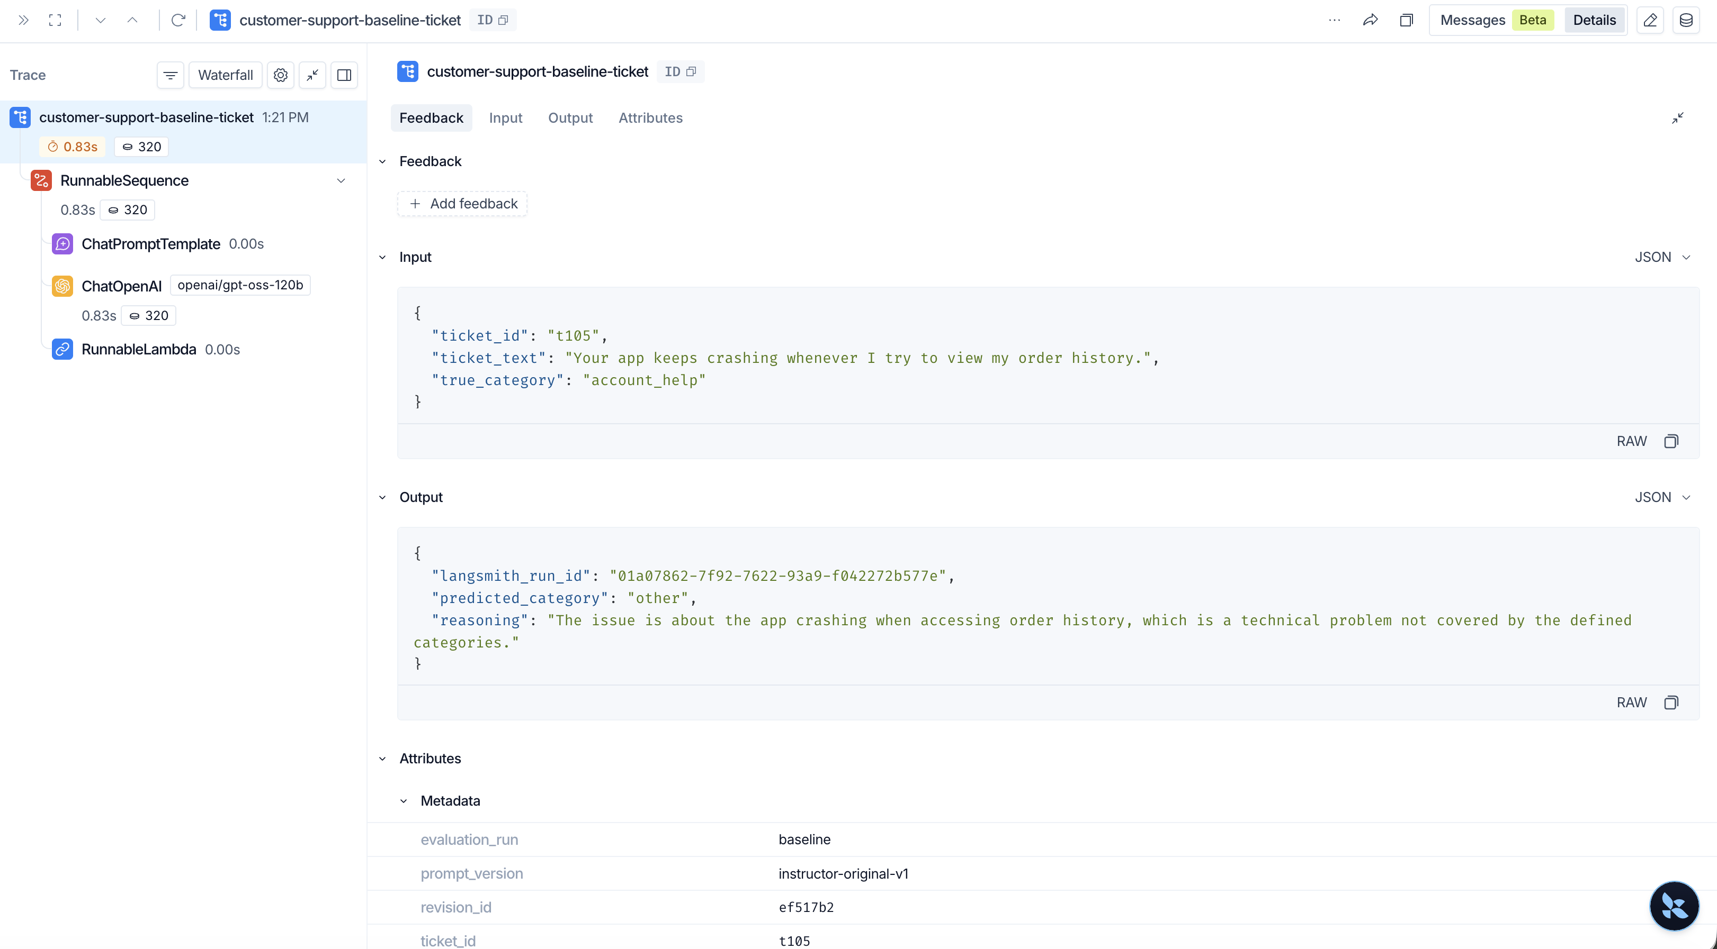
Figure 1 Baseline trace for ticket t105

LangSmith Improved Trace
The improved run used the same ticket and model. The prediction changed to account_help, and the reasoning explicitly cited the new disambiguation rule.
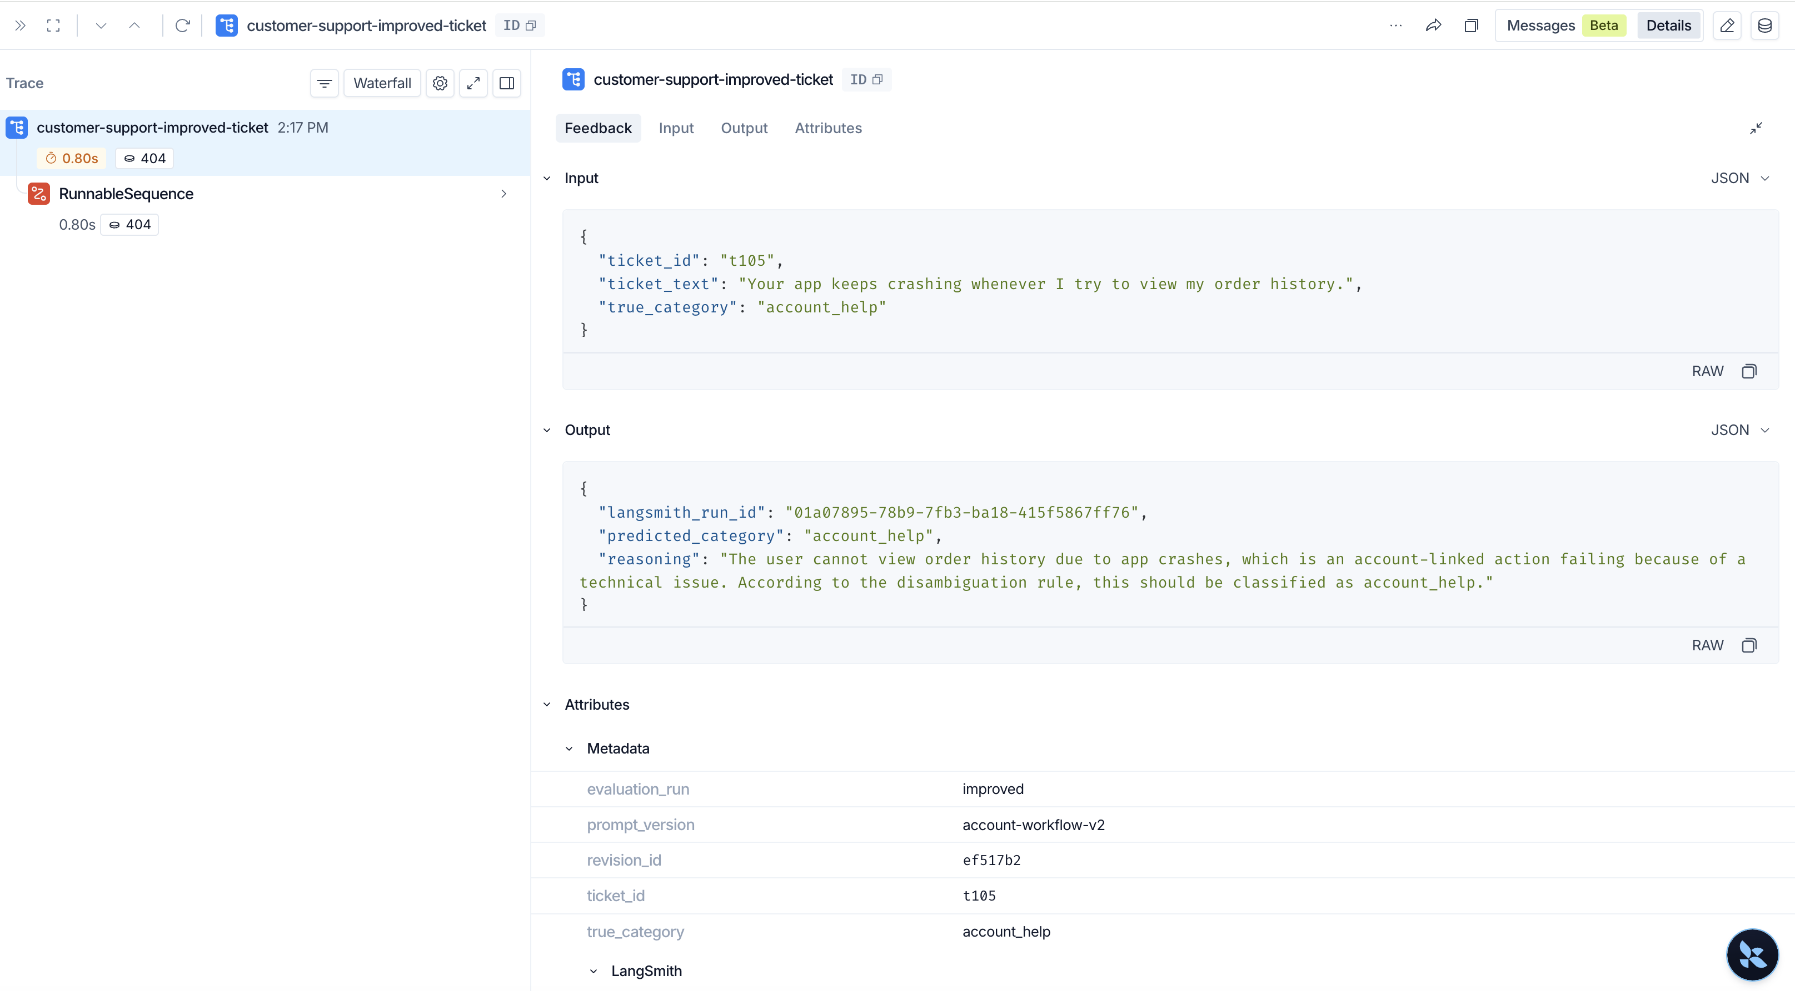
Figure 2 Improved trace for ticket t105

Trace Findings
Case | Baseline | Improved | Finding
t105 app crash | other | account_help | The new rule covered account history access
t114 promo code | other | account_help | A rejected checkout code moved into account help
t117 missing record | order_status | account_help | A missing account record no longer looked like tracking
t050 price adjustment | refund_request | other | One regression exposed a separate refund boundary gap

System Health
The inspected traces completed successfully and contained the expected prompt model and parsing spans. The incorrect decisions were policy failures rather than API execution or output parsing failures.

LLM As A Judge

Judge Task
The optional binary judge evaluated all 29 instructor reference failures. It saw the customer message and the classifier's incorrect predicted intent but did not see the human failure label. It returned TRUE when the error matched Account Workflow Missed and FALSE otherwise. The human labels contained nine TRUE and 20 FALSE cases.

Model Comparison
Judge model | Agreement | p50 | p95 | Tokens | Decision
openai gpt oss 120b | 100% 29 of 29 | 0.772 s | 1.119 s | 13,945 | Selected
Qwen3 235B | 100% 29 of 29 | 0.927 s | 1.283 s | 10,046 | Comparison

Both models achieved perfect precision recall and F1 for both classes. No prompt calibration was justified because there were no mismatches. We selected gpt oss 120b because it was faster and gave shorter explanations. Qwen used fewer tokens but was slower and more verbose.

Representative Judge Decisions
Case | Human | Judge | Reasoning check
t103 | TRUE | TRUE | Repeated logout during payment met both rubric conditions
t024 | FALSE | FALSE | A wrong delivery address triggered the delivery exclusion

Regression and Next Evaluation Cycle

Remaining Regression
Ticket t050 asks whether an item that went on sale after purchase qualifies for a price adjustment. The improved prompt changed its prediction from the correct refund_request route to other. The model reasoning states that a post purchase price adjustment does not fit the listed categories.

Reason for Deferring the Fix
Fixing t050 requires a second prompt intervention that explicitly maps post purchase price adjustments to refund_request. Adding it to the current run would combine two changes and weaken attribution of the measured improvement. We therefore documented the regression and reserved the fix for a new prompt version.

Recommended Next Experiment
Step | Action | Regression check
1 | Add one price adjustment rule to refund_request | Keep the account workflow rule unchanged
2 | Rerun the same 150 tickets as prompt version 3 | Compare every case with version 2
3 | Inspect all discount related cases and prediction flips | Separate post purchase adjustments from pre purchase discounts
4 | Accept the rule only if t050 is fixed without new errors | Retain trace IDs latency and token metrics

Production Monitoring
Monitor labeled routing accuracy below 95 percent, recurrence of account-workflow failures, regression rate above 1 percent, p95 latency above 1.5 seconds, and token usage more than 25 percent above the improved baseline.

Conclusion
The project produced a measurable classifier improvement and a reusable evaluation workflow. Human review identified the error structure. The fixed dataset made the experiment comparable. LangSmith connected aggregate metrics to individual decisions. Regression testing exposed the remaining refund boundary gap. The judge comparison showed how to validate an automated evaluator against human labels before relying on it.

